Mitigating Asymmetric Power Dynamics through Mobile Privacy Negotiation in Smart Homes
Authors: Hasan Malkoç, Gizem Aleyna Tuzcu
Abstract
The development of smart home technology has created complex social problems related to the privacy of bystanders, or those who live in or visit smart IoT devices but do not own them, such as visitors and domestic staff. Current smart house designs often follow a "autocratic" approach, allowing homeowners ultimate control over data gathering while leaving viewers with minimal agency or capacity to object. In order to enable real-time privacy negotiation, this paper offers a mobile Progressive Web Application (PWA) as a technological solution. The program bridges the gap between homeowner security and bystander privacy through the use of role-based dashboards, automatic privacy modes, and a request-response protocol.
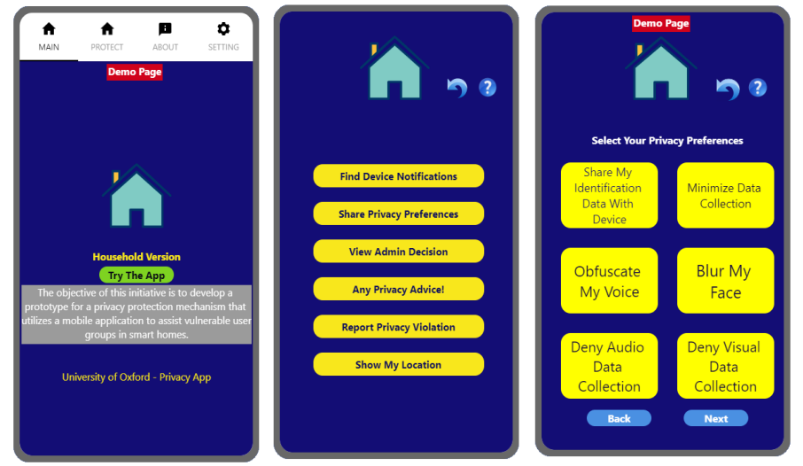

1. Problem Statement: The Autocratic Smart Home
Smart technology such as cameras, microphones, and behavioral sensors are becoming increasingly common in the home. However, research shows that around 73% of visitors are uncomfortable with smart home surveillance. The main issue is the unbalanced socioeconomic power relations that exist in these situations, where homeowners have the "privilege" of data collecting but guests and workers have no impact. In situations such as the Muslim Arab Middle Eastern (MAME) area, patriarchal systems and religious values complicate these dynamics even further. Vulnerable groups, especially foreign female domestic workers, frequently give up their privacy rights in order to keep their jobs or avoid confrontation, thereby normalizing a life of continual surveillance. Existing technical privacy tools often fail to address these issues because they require router access or technical expertise that is inaccessible to most bystanders.

2. Proposed Solution: The Privacy Negotiation PWA
To address these power imbalances, we developed a full-stack, mobile-first PWA that facilitates a collaborative relationship between hosts and guests. The application is built using a modern, type-safe stack featuring React 18, TypeScript, and Vite. Centralized state management is handled by Zustand, which acts as the system's "Policy Engine" to manage real-time device states and UI themes.
2.1 Automated Privacy Modes and Logic Layer
The solution provides three pre-configured privacy modes designed to balance host security with guest comfort.
The Security Mode prioritizes home protection by keeping all sensors and cameras active for maximum security.
The Social/Guest Mode is optimized for social interaction; it triggers a "Mask" state for cameras in common areas while keeping smart speakers active for music or information.
Finally, the Private/Prayer Mode provides maximum privacy by disabling all recording devices in specific rooms to accommodate cultural or religious needs, such as changing clothes or prayer. A dedicated logic layer maps these selected modes to specific hardware commands, providing immediate visual feedback across the app via status badges.
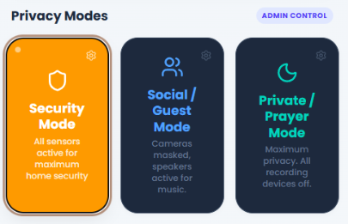
2.2 The Negotiation Protocol and User Experience
The application empowers bystanders through an asynchronous request system. Guests can view a real-time inventory of all active smart devices, organized by room for better context.
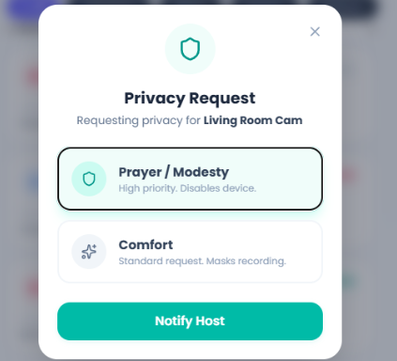
If a guest feels uncomfortable, they can discreetly submit a "Privacy Request" for a specific device, such as a "Comfort" request to mask recording or a high-priority "Prayer/Modesty" request to disable the device entirely.
The host dashboard then receives an "Action Required" notification, allowing the homeowner to approve or deny the request in real-time. This workflow replaces the "autocratic" model with a collaborative negotiation process.
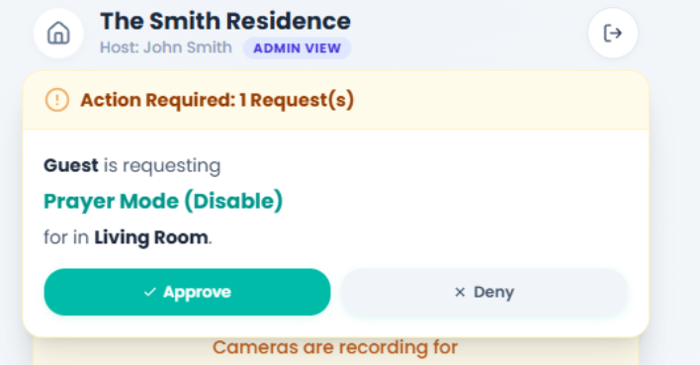

3. Design Philosophy and Security Considerations
The system adheres to established principles of privacy-by-design and responsible innovation. To lower the barrier for guests, we implemented a zero-config authentication method where users enter a simple 4-digit home code to gain instant access without downloading an app.
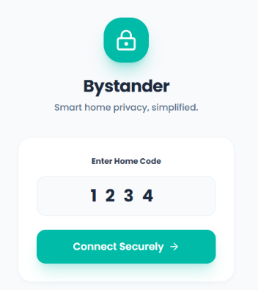
The system emphasizes transparency by providing clear explanations of what data each device collects or stops collecting in its current state. From a security standpoint, the application utilizes a simulated connection that respects the host's network and requires no intrusive configurations. Furthermore, the system practices data minimization by requiring no personal data from the guest to remain functional.

4. Conclusion and Future Enhancements
This project transforms academic research on smart home power dynamics into a usable, human-centered security solution. Successful test scenarios revealed complete synchronization of mode selection and device status display across various settings. Future development will include resolving competing privacy demands from several visitors at the same time, as well as combining the PWA with Home Assistant and Matter protocols to manage physical objects. Also, including QR code instead of manually entering the PIN code will speed up the authentication process. The application seeks to defend the basic right to privacy in increasingly monitored household areas by filling the gap between technical blockage and social negotiation.

